16-bit ASN

🌐 What Is 16-bit ASN?
# Source: Chatgpt (GPT‑5 Mini) at [12/15/2025]
A 16-bit ASN (Autonomous System Number) is a unique identifier consisting of 16 bits (2 bytes) used in Border Gateway Protocol (BGP) to identify an Autonomous System (AS) — a network or group of networks under a single administrative domain that shares a common routing policy.

🧠 Simple Definition:
# Source: Chatgpt (GPT‑5 Mini) at [12/15/2025]
A 16-bit ASN is a number between 1 and 65,535 used to identify a network on the internet for BGP routing.

🧾 Range of 16-bit ASNs
# Source: Chatgpt (GPT‑5 Mini) at [12/15/2025]
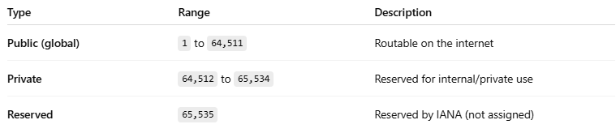

Type | Range | Description
Public (global) | 1 to 64,511 | Routable on the internet
Private | 64,512 to 65,534 | Reserved for internal/private use
Reserved | 65,535 | Reserved by IANA (not assigned)

📚 Example Use
# Source: Chatgpt (GPT‑5 Mini) at [12/15/2025]
A router that belongs to AS65001 will advertise BGP routes as:
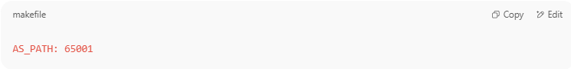
AS_PATH: 65001

If a packet crosses:
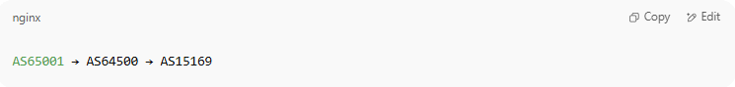
AS65001 → AS64500 → AS15169

The AS path in BGP updates would be:
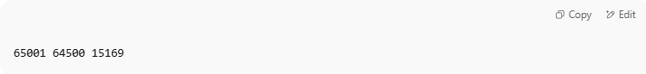
65001 64500 15169

⚠️ 16-bit Limitations
# Source: Chatgpt (GPT‑5 Mini) at [12/15/2025]
Originally, only 16-bit ASNs were available, which limited the total to 65,536 unique ASNs. As the internet grew, this pool became too small.

🧩 Solution: 32-bit ASNs
# Source: Chatgpt (GPT‑5 Mini) at [12/15/2025]
To overcome the limitation, 32-bit ASNs were introduced in 2007, allowing 4,294,967,296 possible ASNs.

🆚 16-bit vs 32-bit ASN
# Source: Chatgpt (GPT‑5 Mini) at [12/15/2025]
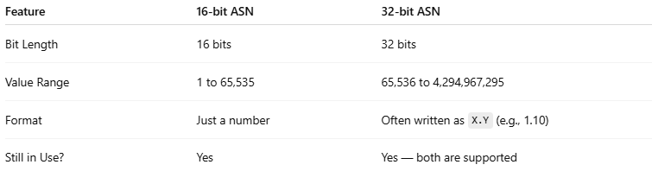

Feature | 16-bit ASN | 32-bit ASN
Bit Length | 16 bits | 32 bits
Value Range | 1 to 65,535 | 65,536 to 4,294,967,295
Format | Just a number | Often written as X.Y (e.g., 1.10)
Still in Use? | Yes | Yes — both are supported

✅ Summary
# Source: Chatgpt (GPT‑5 Mini) at [12/15/2025]
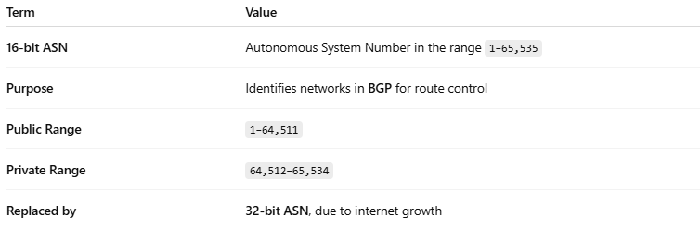

Term | Value
16-bit ASN | Autonomous System Number in the range 1–65,535
Purpose | Identifies networks in BGP for route control
Public Range | 1–64,511
Private Range | 64,512–65,534
Replaced by | 32-bit ASN, due to internet growth

